[[Protoype]]

* Hidden property
* Either null or references another object

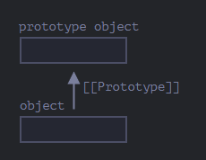

Setting using __proto__ (bad way, just for concepts)

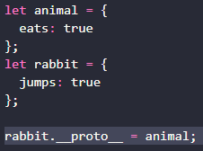

Now if we read a property from rabbit and it’s missing, it will go look in the animal (it’s prototype) if there are properties that you indicated



Another representation:

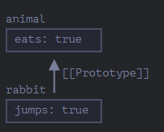

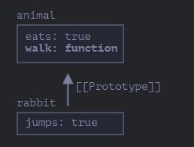

The prototype chain can be longer:

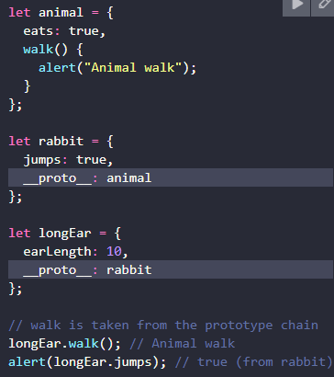

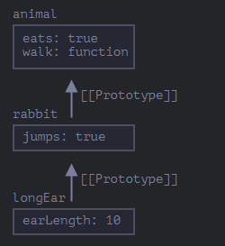

Two Limitations:

1. References can’t go in circles. JS will throw an error if we try to assign __proto__ in a circle.
2. __proto__ can only be:
   1. Object
   2. Null

Note: THERE CAN ONLY BE ***ONE*** PROTOTYPE PER OBJECT.